**ISM 354 Group Project**

Heinrich De Lange (18311792)

Justin Smith (17623057)

Paul Theron (18928994)

Ryan Evans (17621917)

Table of Contents

1. Introduction 3

2. User Pages/Static Functions 4

2.1 Landin Page/Welcome Page 4

2.2 Meet the team 5

2.3 Terms and conditions 6

2.4 Privacy policy 6

3. User Functions 7

3.1 Log in screen (user) 7

3.2 Dashboard (user) 8

3.3 View profile 8

3.4 Accounts 9

3.5 New account 10

3.6 Add recipient 10

3.7 Payments/transfers 11

3.8 Transfers 12

3.9 Buy/pay from external vendors 12

3.9 Ticket 13

3.10 Transaction history 14

# 1. Introduction

Online banking enables the customer to do transactions virtually anywhere, by giving a user access to their accounts via the internet. The implementation of banking apps has given customers more freedom to handle financial matters in simple and efficient ways. The banking app developed offers a wide range of features to the user, allowing them to make payments, enter details and much more.

This application is created for the clients of the Bank of SUN and will help them manage their funds and different accounts. Putting the client in control to navigate the site and conduct their desired business. For the project we assume that all the clients will provide adequate information about external vendors when applying for an account, thus the app will have the external vendors which the user utilizes linked with their account to make payments and purchases. That beneficiaries added will be saved in the data base. We assume the user is a customer or a potential customer of the bank of sun. The documentation below will ensure easy use of the application and supply some knowledge about the logic of each function.

# 2. User Pages/Static Functions

## 2.1 Landin Page/Welcome Page

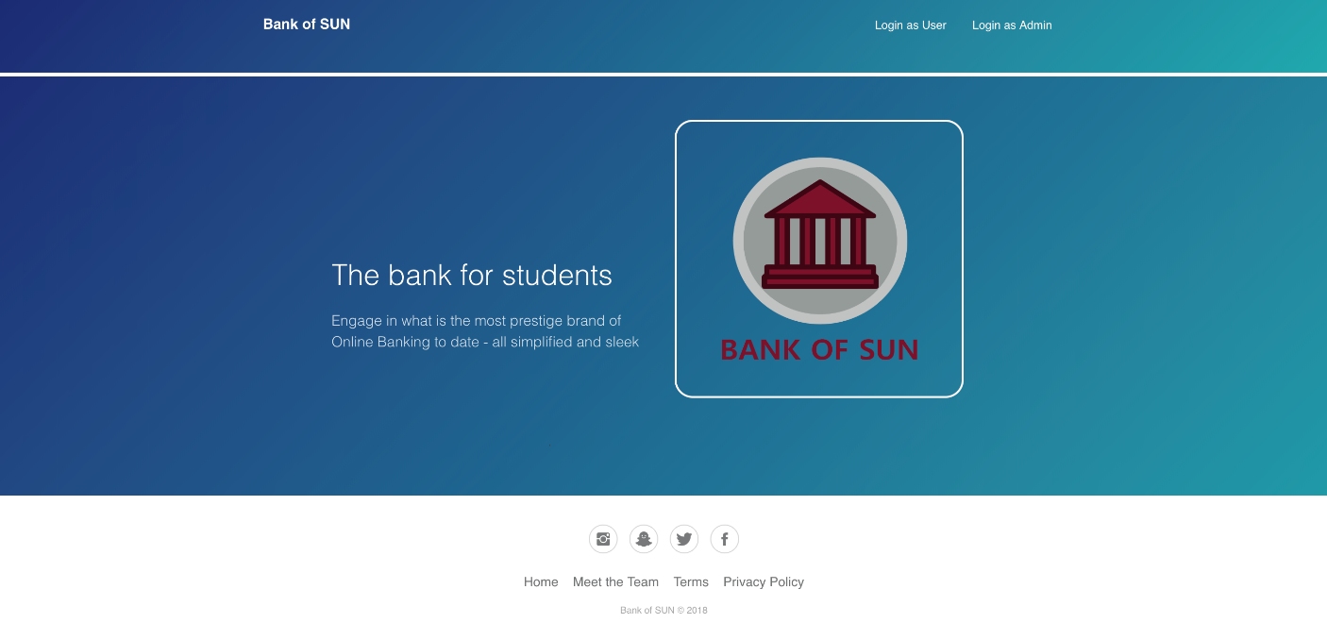

This is the current Homepage where all users will be directed to once connecting to Bank ff Sun’s website. There are two navigable options available. Firstly, there is a client login which is “login as user”, the client/user enters their credentials i.e. their and username and password, which enables the API to process the request. This will generate a specific token to the user which will only be valid during each Login Session. This token pulls the user’s information from the API and allows them to login to their account. The user is then able to view the footer which has various links to information regarding the bank.

## 2.2 Meet the team

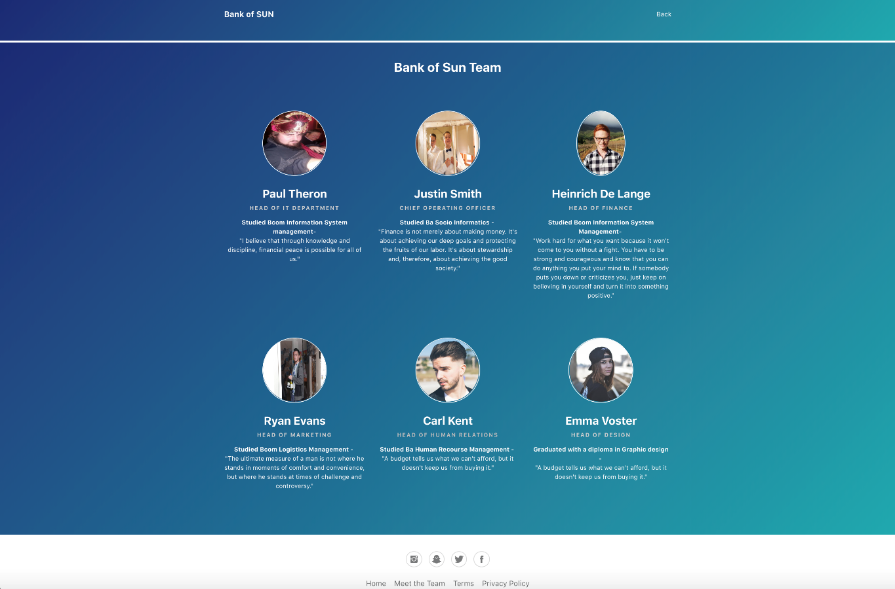

Meet the team is one of the link pages in the footer of the website, this takes the user to a static html page where the user can see the team who work and run the Bank of Sun. They can see a picture of each employee, their position, degree studied and a quote relating to something they feel is important.

## 2.3 Terms and conditions

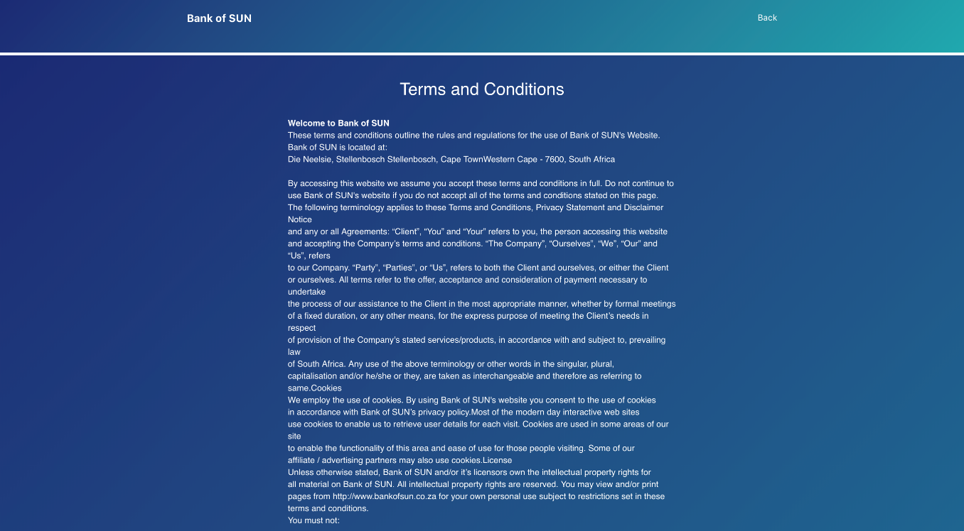

The next footer link is the terms and conditions page. This is a static html page that just displays all the terms and conditions that the bank holds. The user can read through these terms and conditions on this page.

## 2.4 Privacy policy

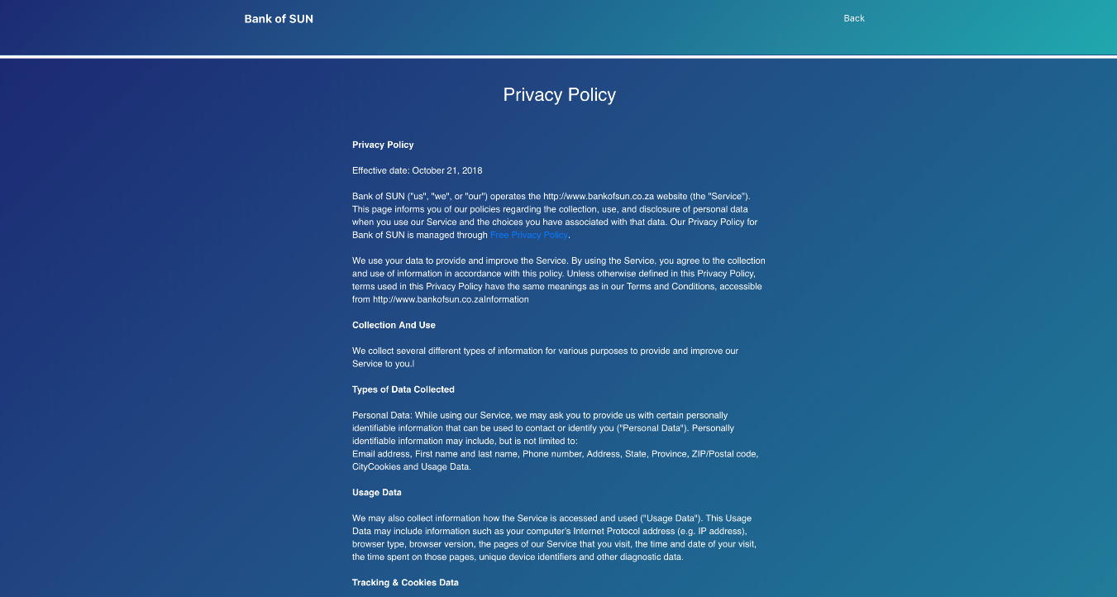

The privacy policy is included in the footer. This static html page just displays the privacy policy of the bank and the website operated by the. This page just states the privacy policy incorporated by the bank as well as other privacy information that a user can read through. This is visible to the public (clients, non/potential clients).

# 3. User Functions

## 3.1 Log in screen (user)

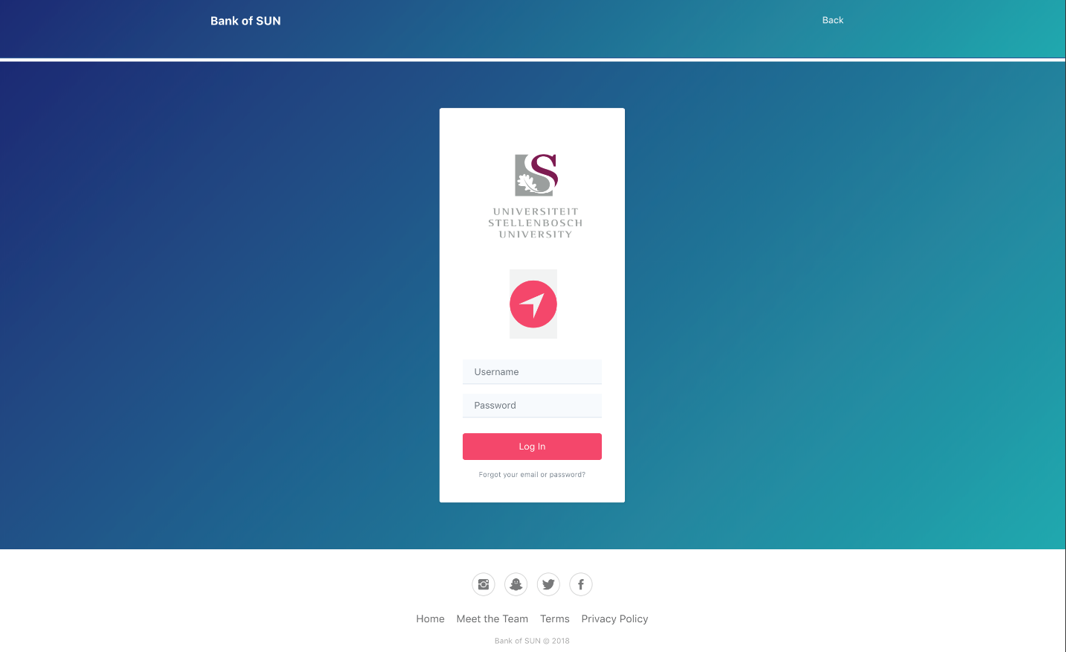

The login page is used when the client/user then enters their credentials (username and password), this then pulls the users information from the API and allows them to login to their account if the credentials are correct. By clicking the Login Button after entering the required information, the system will grant or deny access depending whether the enter data is correct. The system will then take the user to their home page.

## 3.2 Dashboard (user)

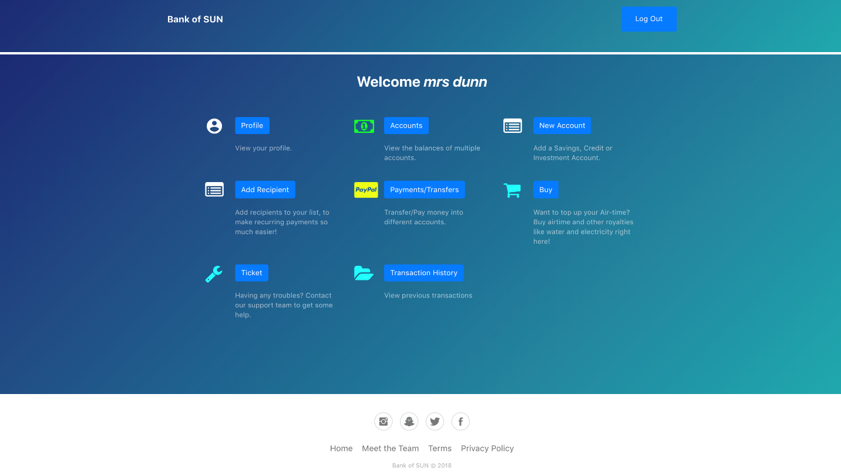

The system will identify the user as a client and locate the ID/profile connected with the username and password by sending the request to the API and retrieving this information. This page displays all the functions that are the user can make use of such as view profile, payments etc.

## 3.3 View profile

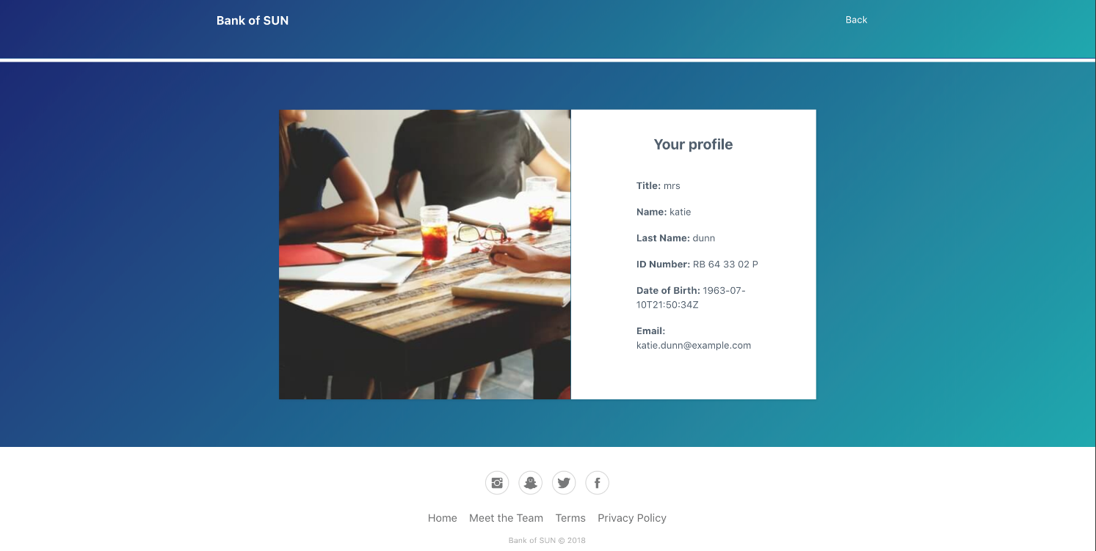

When a user clicks the “view profile” button, this redirects the user to view their profile. This is done by the system calling a request from the API that retrieves the user's details – title, name, last name, ID number, date of birth and email address. This then prints the information in a div in a column.

## 3.4 Accounts

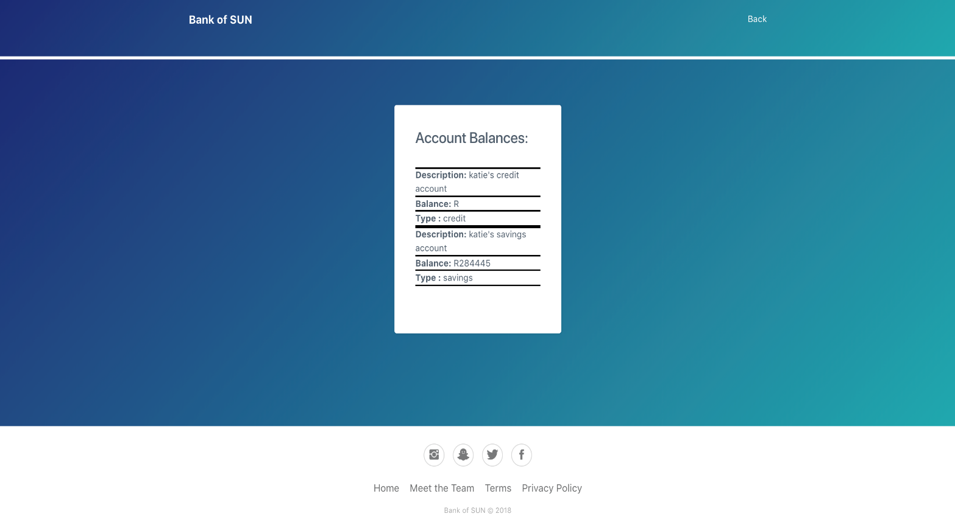

The user can click on the “accounts” button to view their account information such as their different types of accounts, balances etc. The system calls a request from the API in the same way as the view profile function by retrieving the user’s account details – description, balance, type. It is printed in a div in a column.

## 3.5 New account

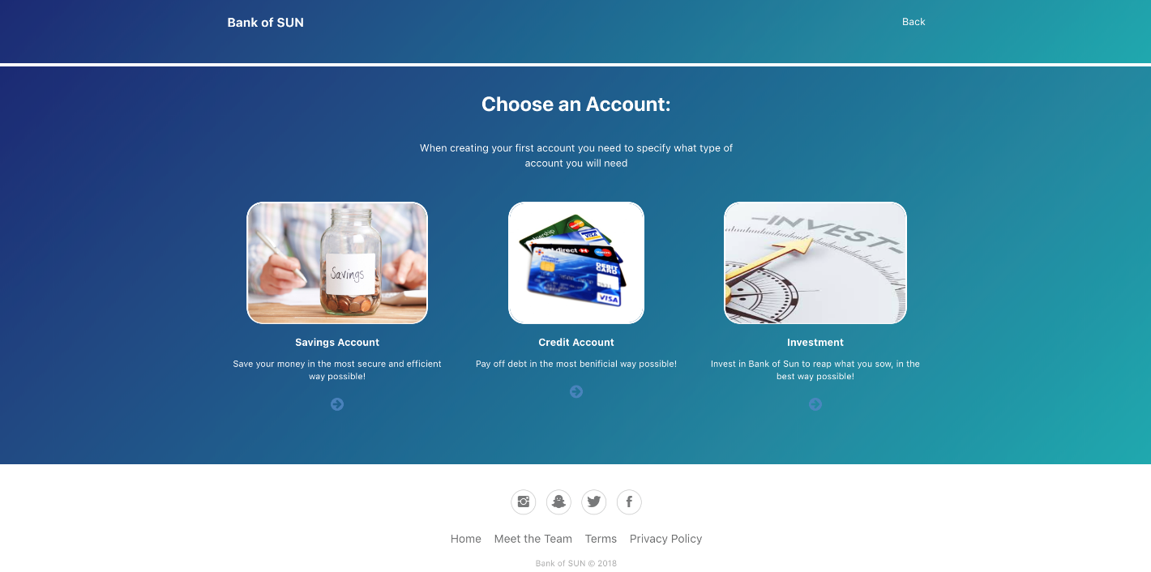

If the user clicks the “new account” button, this redirects them to a page which generates a pop-up message notifying them that they will need to go to into the bank to apply or open a new account.

## 3.6 Add recipient

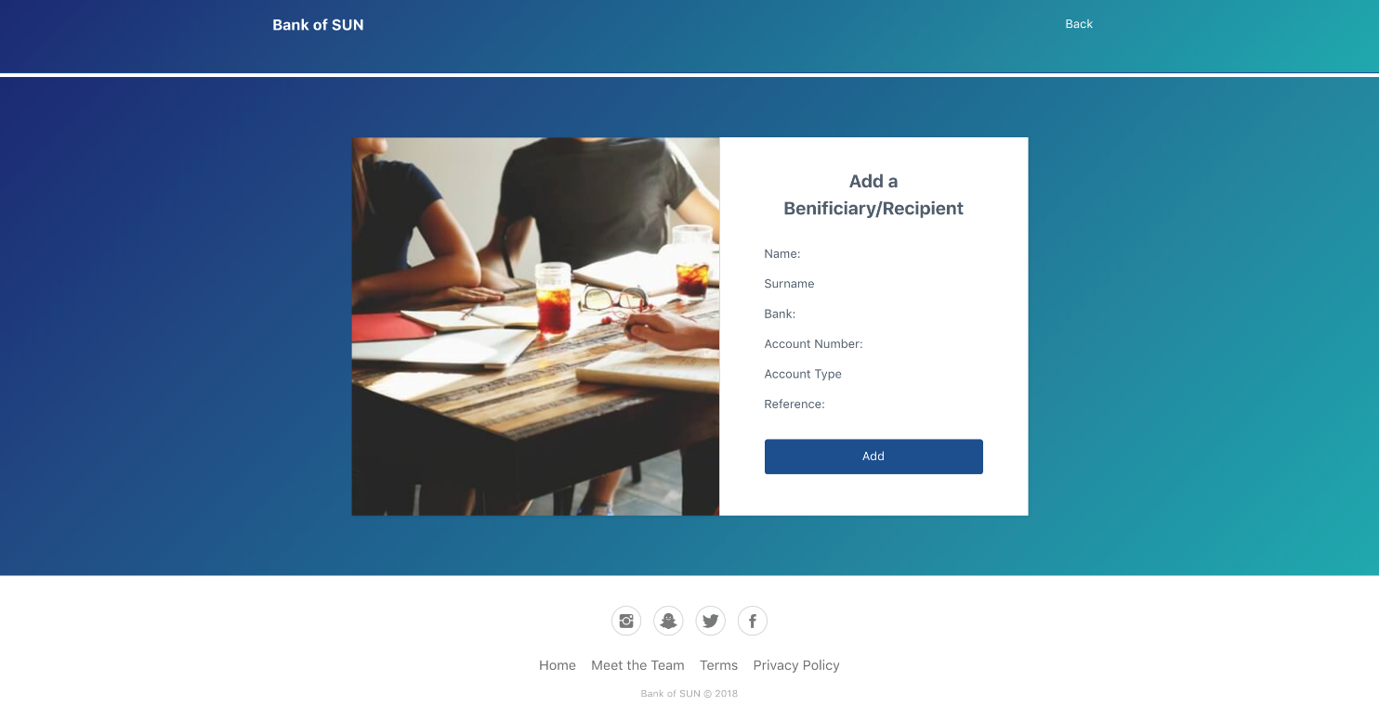

The form will gather personal information for repetitive payments to a recipient/beneficiary, the details will be recorded into a database and added to a list that will be provided for users in the transactions/payment function, simply by clicking on the ADD button after entering the data. This allows users to make payments more efficiently, by having the required data stored within their account (ID) on the system already. **Note * This bares no functionality and only displays static information.**

## 3.7 Payments/transfers

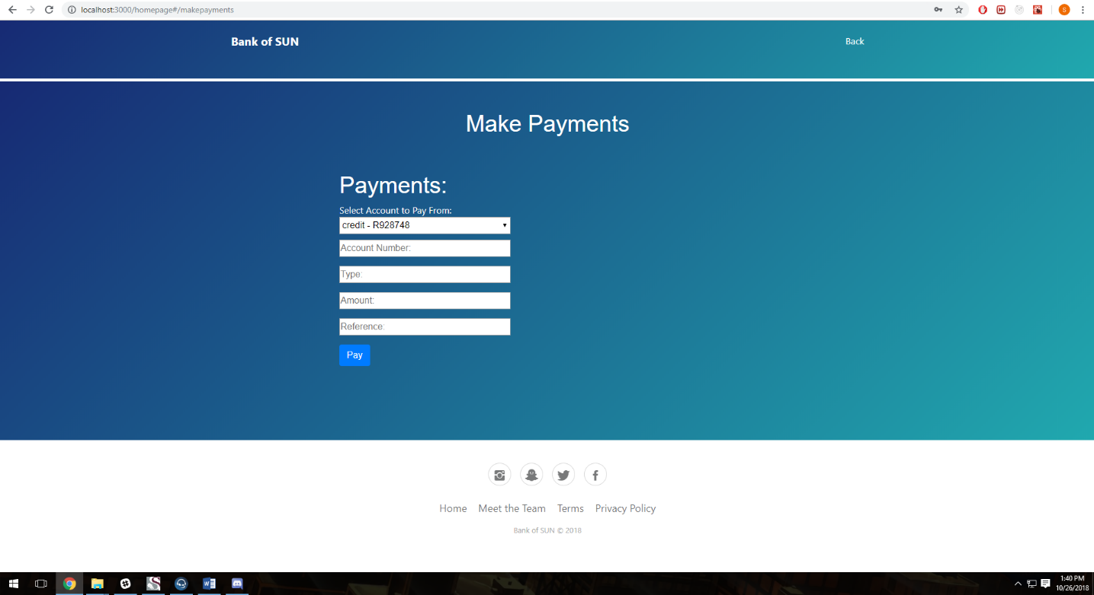

The user can select “Payments” button which redirects them to the payments page where they are able to make payments from one of their accounts to another person’s bank account with another bank, the user enters the information (bank name, amount, reference) then chooses which account they want to make the payment out of through the drop down list. The system then processes this payment and deducts the value of the payment from the specific account that the payment was made from.

**Note:**

* Please do not input a comma in the Account Number.
* Please only use a string value when entering in the Type field.
* Please enter a string value when using the Reference field.
* Please enter a integer amount in the Amount field.

## 3.8 Transfers

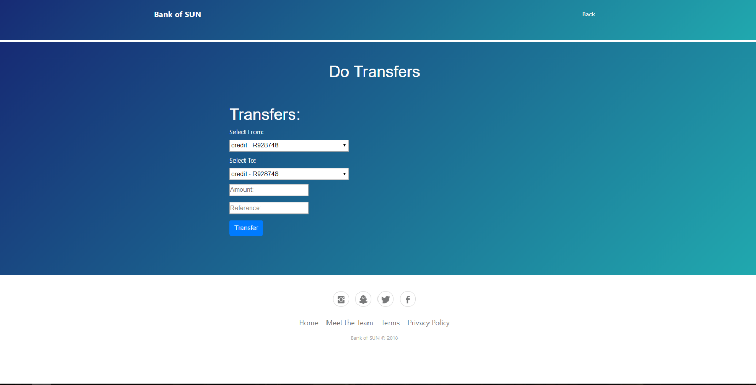

This function is the transfer option. The user can select an account they have (such as cheque) and transfer funds to another account they hold (savings), the system will then transfer the amount from one account to the other account.

**Note:**

* Please enter a string value when using the Reference field.
* Please enter a integer amount in the Amount field.

## 3.9 Buy/pay from external vendors

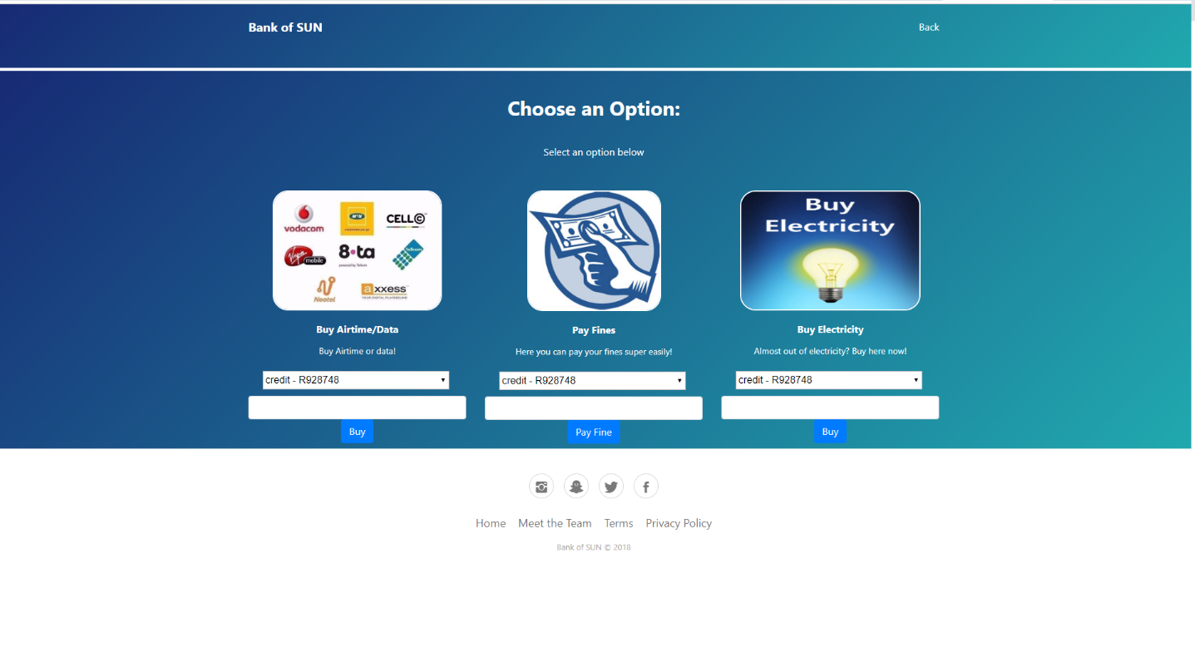This page will have stored data about the user, which the bank received upon the application process for an account. The bank will link airtime/data, electricity and fines with each unique vendor that the user indicated as companies they have an account with. This will help the user buy airtime/data and electricity, as well as pay fines by deducting funds from the user and sending these funds to the unique vendor for the separate transaction. The user will enter the desired amount in the field provided and select with which account they want to pay/buy it from by selecting the desired button.

## 3.9 Ticket

When a user creates a ticket, the system pushes the query to the API. When the user presses the submit button, the query will be posted on screen, and the user can then decide to remove or get all other queries. The frequently asked questions on the ticket page will help the user deal with problems that they may occur and communicate the basic functions to the user. The “click here” button enables the user to create a ticket to ask questions that is not resolved by the FAQ’s.

## 3.10 Transaction history

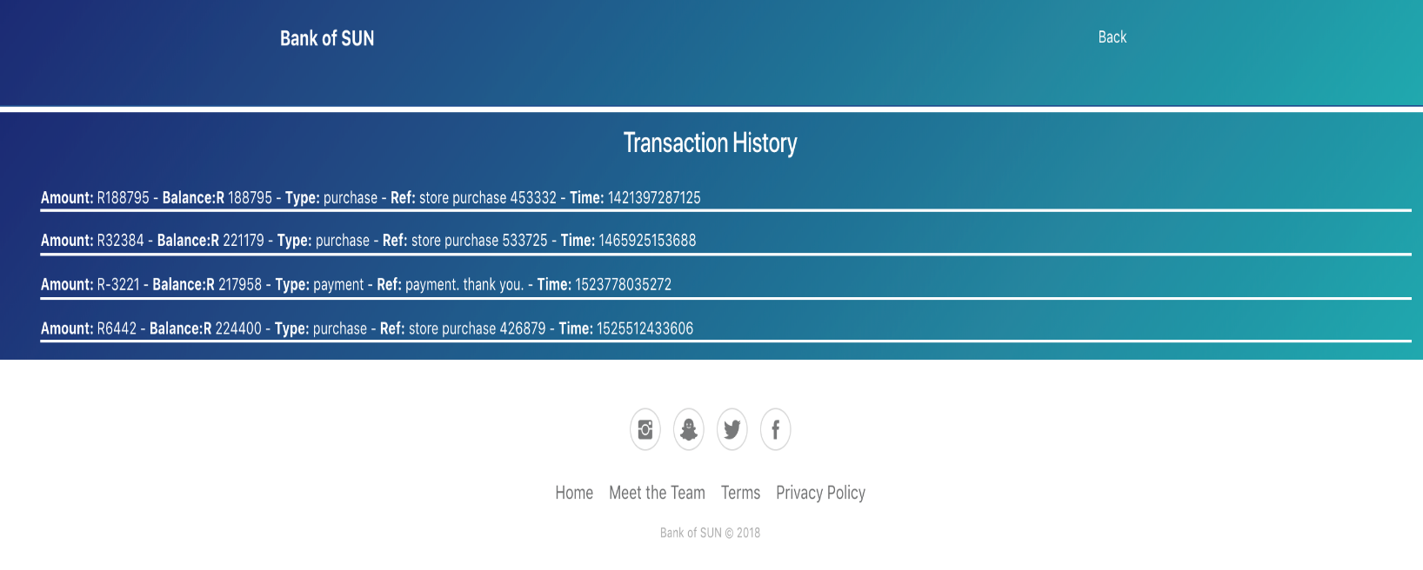

By entering this page, the system will identify the user and display all the transactions that have taken place, it will retrieve all the information from the API pertaining to each individual transaction – amount, balance, type, reference and time.

# 4. User Requirements:

A working Browser along the lines of Mozilla Firefox, Google Chrome, Internet Explorer and a stable and continues internet connection. Either through Mobile, Wi-fi and Ethernet connection.

-